  The Business Centre  527 Moseley Road  Birmingham  B12 9BU  0330 043 8403  0121 256 8043  07886 878 751  legal@godwinausten.co.uk | INVOICE  Invoice: 00-000  Date: 00.00.2026
To:  Mr/Mrs/Ms ……………………………  ……………………….  ……………………….  ……………………….  ……………………….  Delivered via email | For:  Advice re ………………………..  Drafting ……………………..
DESCRIPTION | HOURS | RATE | AMOUNT
See above | Fixed Fee | Fixed Fee | £000.00
TOTAL |  |  | £000.00
Payment Terms: Payment due on receipt of invoice

THANK YOU

Please make bank transfers to (preferred):

Godwin-Austen Ltd
Bank Name: Metro
Sort Code: 23-05-80
Account No: 55072027
SWIFT BIC: MYMBGB2L
IBAN: GB78MYMB23058055072027

IMPORTANT

Please include the invoice number(s) when transferring funds to assist us in identifying the payment.

Detailed Assessment by the Court

- If this is a contentious matter, you have the right to request, within 3 months of receiving this bill (provided we have not begun debt recovery proceedings), that we send you a detailed bill outlining the costs charged.

- Please note, requesting a detailed bill will render the original bill invalid. The detailed bill may reflect a higher amount if the recalculated costs warrant it.

- You are entitled to apply to the Court to have our bill assessed, regardless of whether the bill is contentious or non-contentious. However, you must make the application.

- If you apply within one month of receiving the bill, you have an automatic right to have it assessed. If you apply after one month, the Court may agree to an assessment but could impose conditions. In such cases, we will generally ask the Court to require you to pay the full bill amount into Court while the assessment is pending.

- If more than 12 months have passed since the bill was issued, the Court will typically only order an assessment under exceptional circumstances.

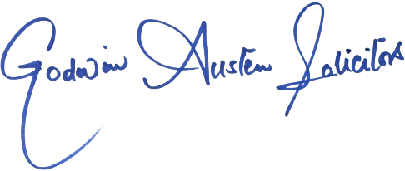
Signed:

